🐧 PART 1 — Create Linux EC2 Instance

Step 1: Go to EC2
- Login to AWS Console
- Search EC2
- Click Launch Instance
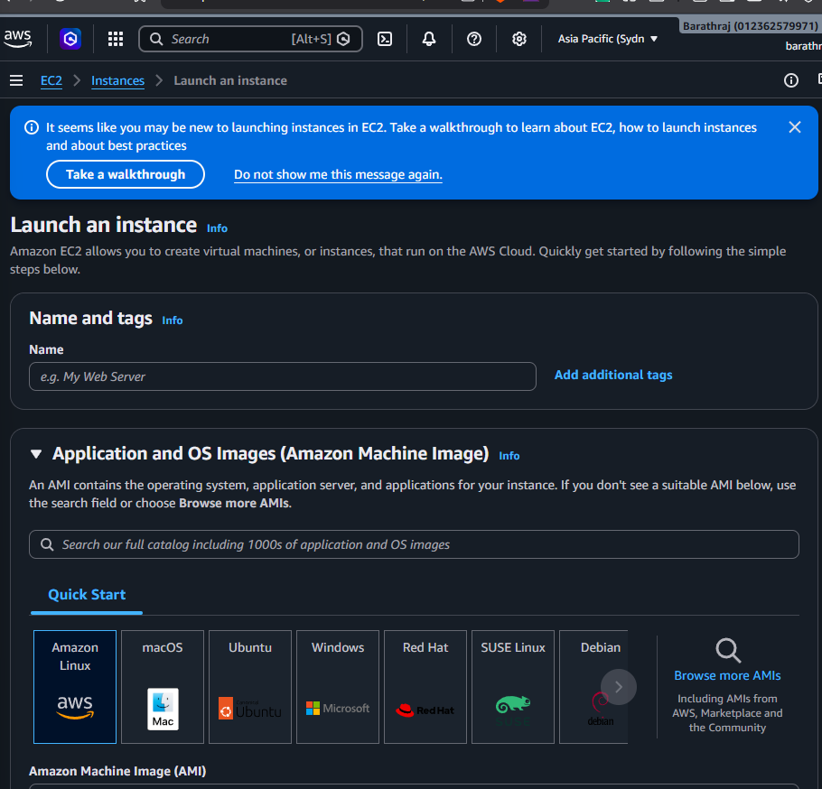

Step 2: Name the Instance
Name:
studentname-linux-vm
Example:
saravana-linux-vm
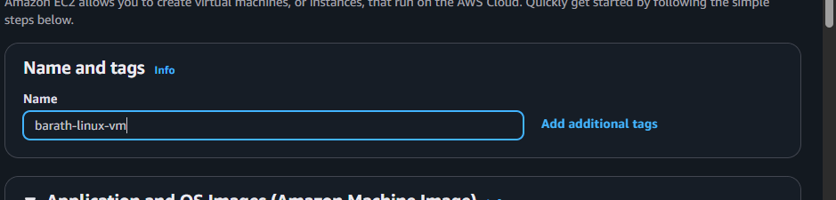

Step 3: Choose AMI
Select:
- Amazon Linux 2023 (Free tier eligible)
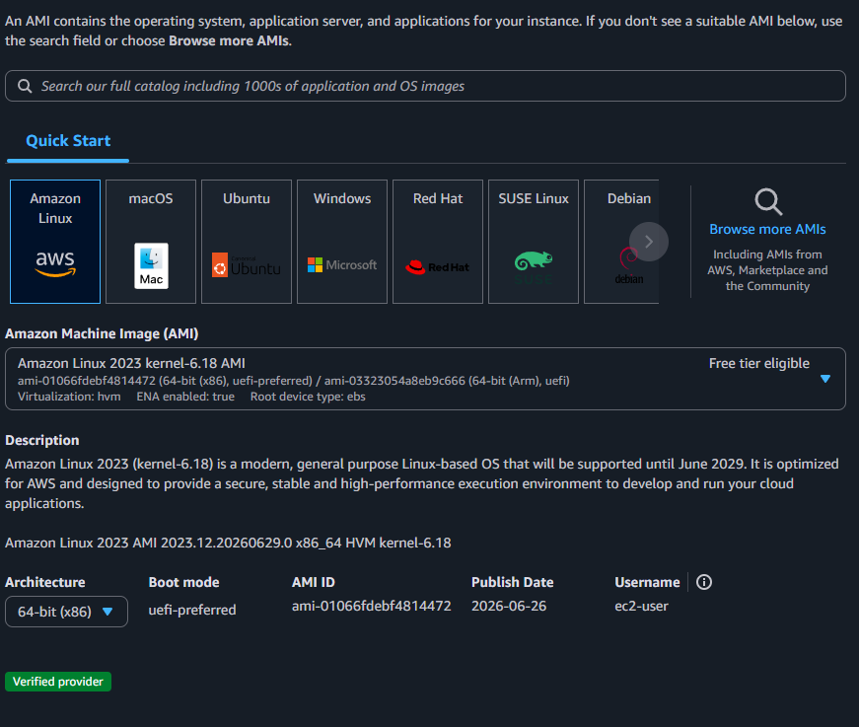

Step 4: Choose Instance Type
Select:
t2.micro
(Free tier eligible)
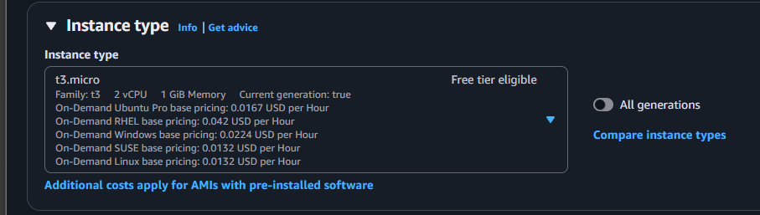

Step 5: Create Key Pair
Click Create new key pair
Name:
studentname-key
Download .pem file.
⚠️ Save safely — cannot download again.
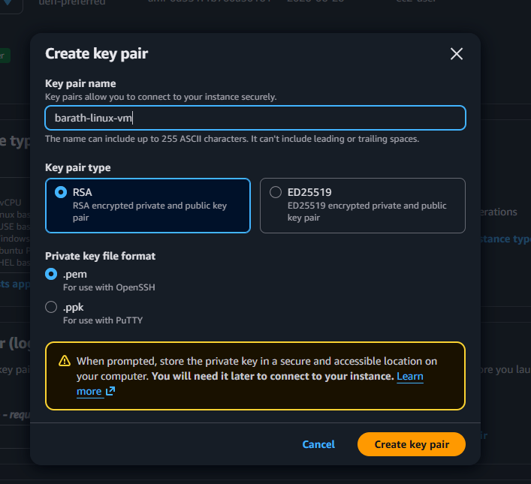
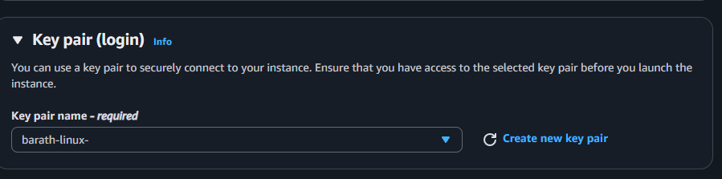

Step 6: Configure Network Settings
Click Edit:
- Auto-assign Public IP → Enable
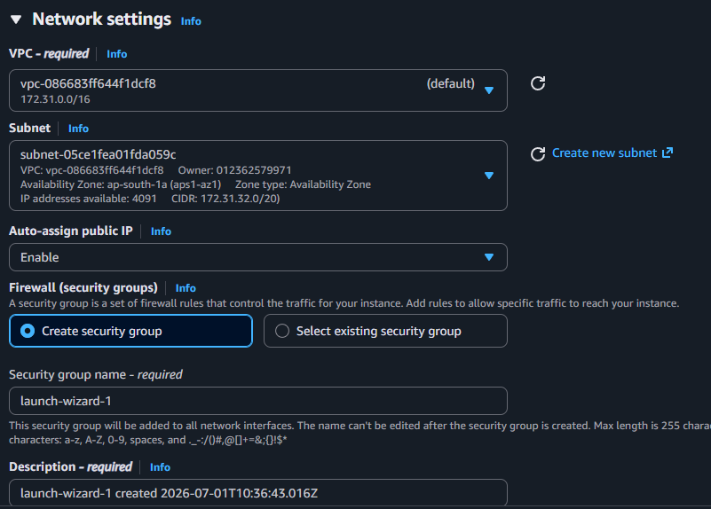
- Create new Security Group
Add Inbound Rules:
Type | Port | Source
SSH | 22 | My IP
HTTP | 80 | Anywhere
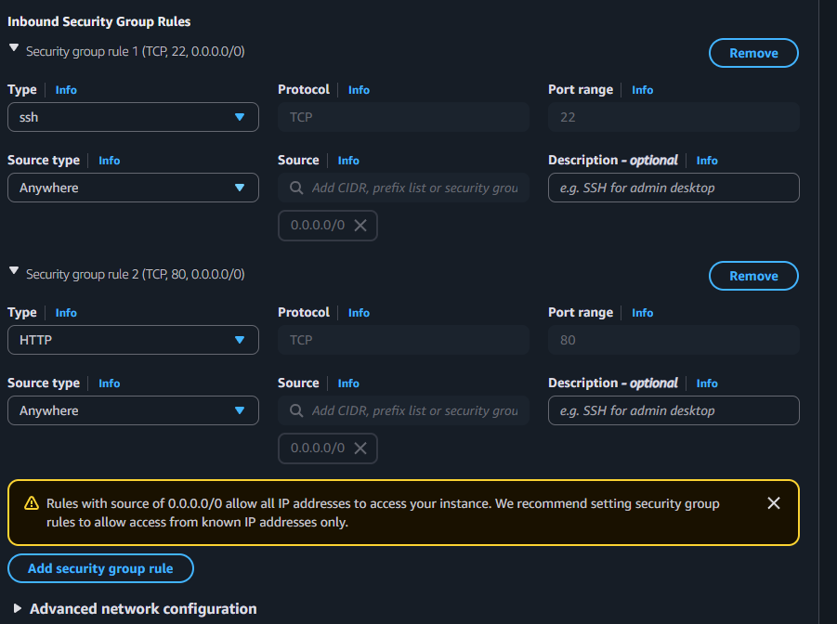

Step 7: Storage
Keep default:
8 GiB gp3
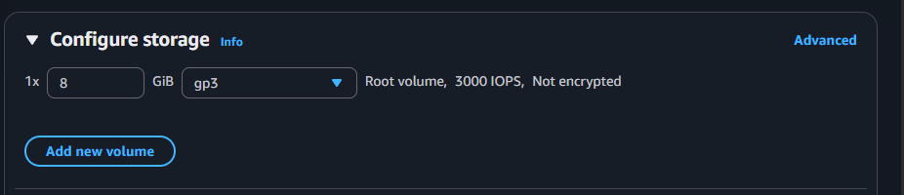

Step 8: Launch Instance
Click Launch Instance
Wait until:
Instance state → Running
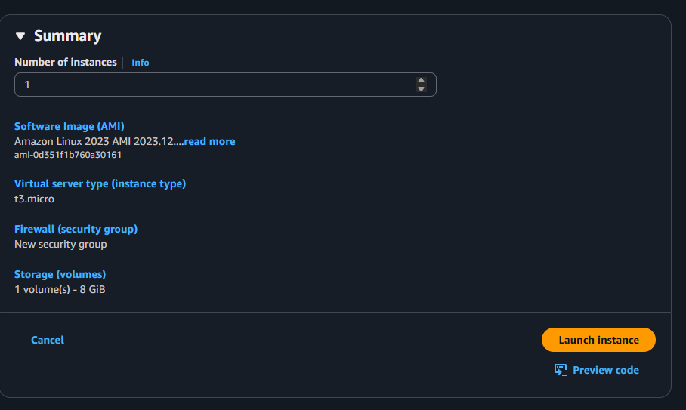
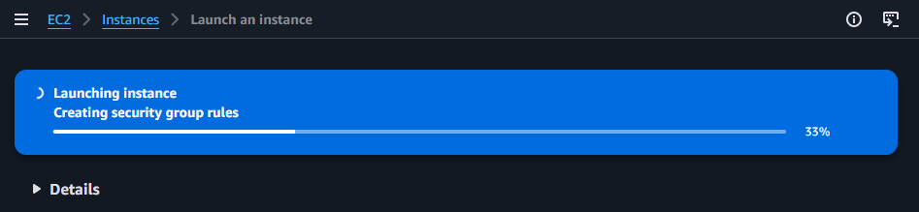

Step 9: Connect to Linux VM
Option 1: EC2 Instance Connect (Browser SSH)
OR
Option 2: From your local system:
chmod 400 studentname-key.pem

ssh -i studentname-key.pem ec2-user@<Public-IP>
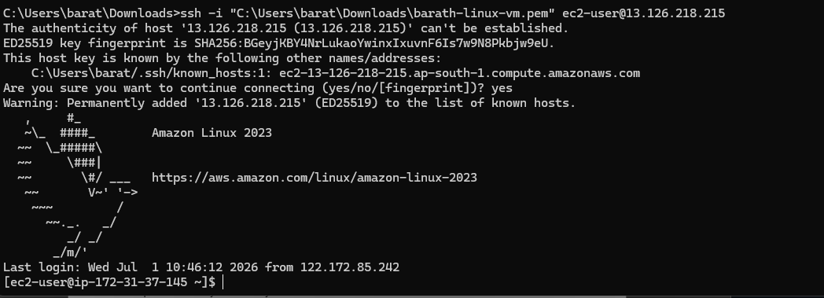

Step 10: Test Web Server (Optional)
Install Apache:
sudo yum install httpd -y
sudo systemctl start httpd
Open browser:
http://<Public-IP>
You should see Apache page.
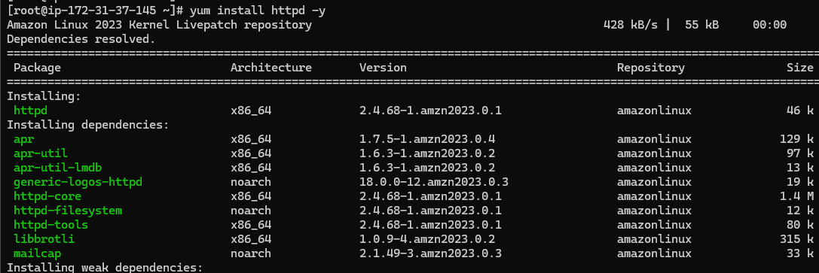

🪟 PART 2 — Create Windows EC2 Instance

Step 1: Launch New Instance
Click Launch Instance

Step 2: Name It
studentname-windows-vm
Example:
saravana-windows-vm
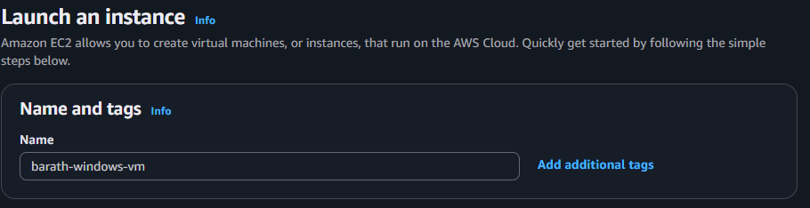

Step 3: Choose AMI
Select:
- Microsoft Windows Server 2022 Base (or) Microsoft Windows Server 2025 Base
- 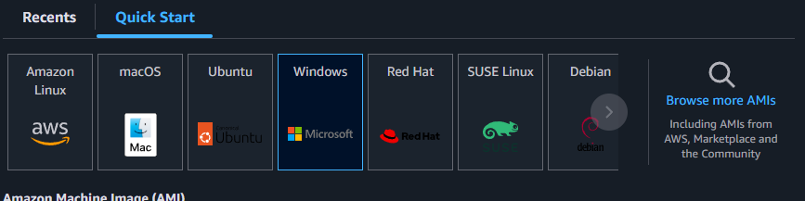

Step 4: Instance Type
Select:
t2.micro
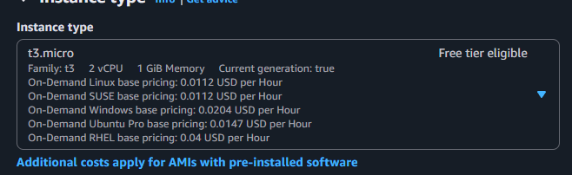

Step 5: Key Pair
Use the same:
studentname-key
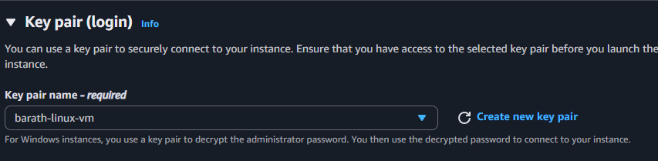

Step 6: Network Settings
Inbound Rules:
Type | Port | Source
RDP | 3389 | My IP
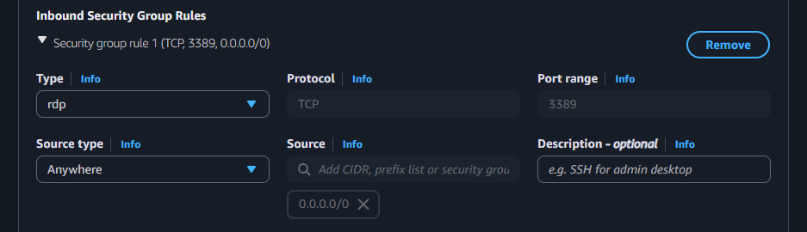

Step 7: Storage
Default:
30 GiB
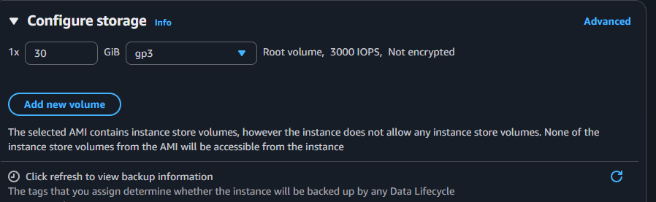

Step 8: Launch
Wait until:
Running
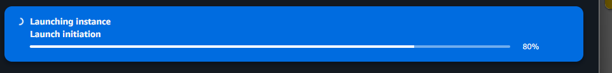

Step 9: Connect to Windows
- Select instance
- Click Connect
- Choose RDP client
- Click Get Password
- Upload your .pem key
- Decrypt password
- Open Remote Desktop
- Connect using:
  - Public IP
  - Username: Administrator
  - Decrypted Password
